STATE OF HAWAI‘I

DRAFT
OFFICE OF HAWAIIAN AFFAIRS

Molokaʻi History Project
145 Ala Malama Street Unit 103
Molokaʻi Island Site Visit Summary
of the Office of Hawaiian Affairs
Board of Trustees
Summary Report
May 15, 2024 – 10:00 am

BOT STAFF:
Lehua Itokazu, Board Secretary
Crayn Akina, Trustee Aide
Joyce Yang, Trustee Aide
Nathan Takeuchi, Trustee Aide
Anuhea Diamond, Trustee Aide
Pohai Ryan, Trustee Aide
Sommer Soares, Trustee Secretary
Kaui Robello, Trustee Aide
Kyla Hee, Trustee Aide
Kauikeaolani Wailehua, Trustee Aide

GUEST:
Mia Lee

ATTENDANCE:
Trustee Hulu Lindsey
Trustee Luana Alapa
Trustee Dan Ahuna
Trustee Keoni Souza

Trustee Brickwood Galuteria

ADMINISTRATION:
Stacy Ferreira, CEO
Kuʻike Kamakea-Ohelo, Dir. of ʻOiwi Well-Being

- Call to Order
Site visit starts at 10:00 a.m.

- Site Visit

Molokaʻi History Project

It is shared that following the passing of Dr. Aluli there was great support by the Molokaʻi community to establish a place where historical and cultural objects could be kept along with Molokaʻi history. Initial discussions of more than fifteen individuals met to brainstorm along with Dr. Pulama Lima, Executive Director of Ipu Makani Cultural Heritage Center. These discussion led to the establishment of the Molokaʻi History Project. The Molokaʻi History Project opened itʻs doors on October 6, 2023 with no means of financial support and a generous landlord. The landlord gave them two months of free rent and a garage sale that paid for their first months rent. They have been open for seven months and have been applying for several different grants, The Moloka’i community continues to support this effort by bringing in photos, articles, cash donations and voluteering as docents. Many residents as well as visitors have joined their membership. At the moment they have one rotating visit changing three times a year.

To date, they have had an approximately 2,200 visitors that have come through. Everything in the museum has been donated or on loan. Every piece is from Molokaʻi and not from outer island. They are looking for to sharing everything about Molokaʻi and to expand their space as they are at full capacity.

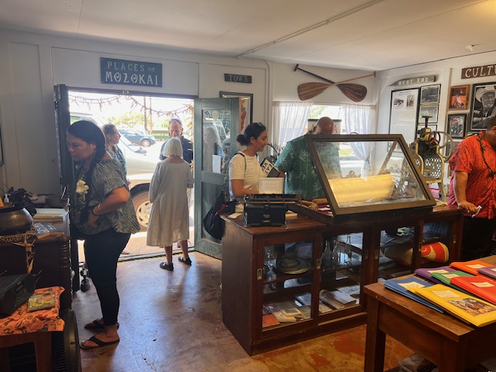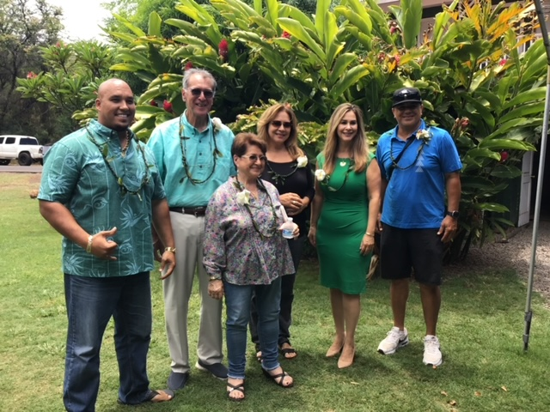

- Public Testimony
None

- Announcements
None

- Adjournment
The site visit ends.

Respectfully submitted,

______________
Lehua Itokazu
Board Secretary

Site Visit Summary Approved at Board of Trustees Meeting on XXXXXXXXXXX.

________________
Carmen Hulu Lindsey
Chairperson, Board of Trustees

Attachments: *all excused memos and handouts will be attached to summary once approved

